Underground Railroad Network to Freedom Sites:
Photographs and Captions

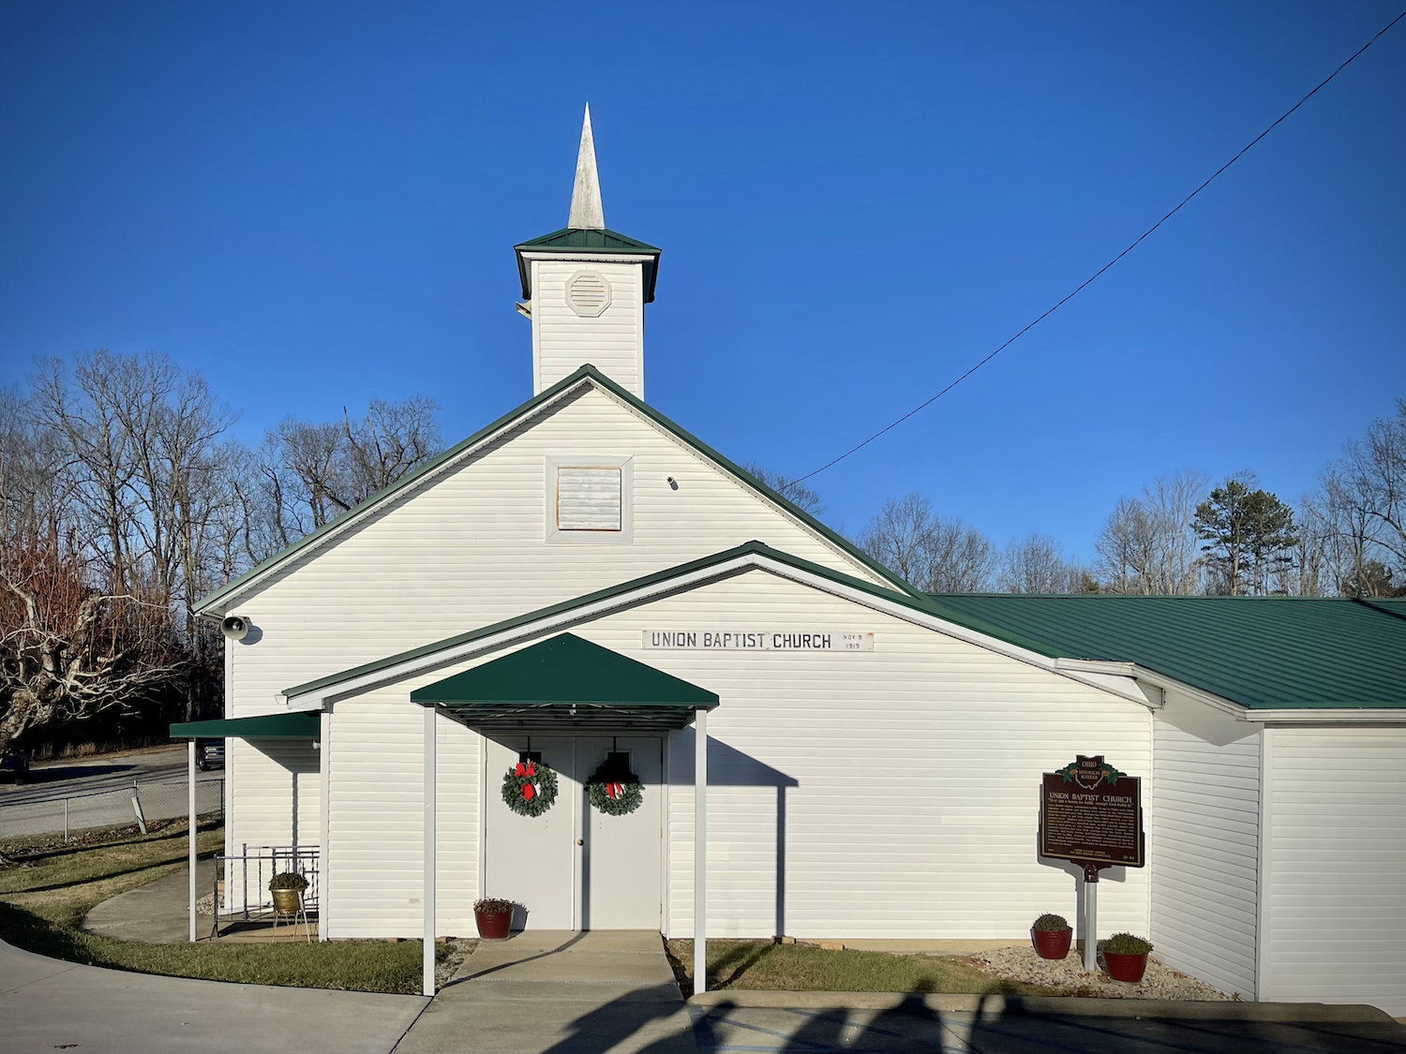
- CAPTION: Union Baptist Church at Blackfork, Lawrence County, Ohio, was founded in 1819 and recognized as the longest continuously active African American church in the state. The congregation’s roots lie in what was originally known as the Stewart Settlement, an early free Black community more commonly referred to today as Poke Patch. Its membership included free Black families and pastors who participated in Underground Railroad activity, and the surrounding settlement functioned as an important station on routes connecting Ironton, Burlington, Macedonia, Red Hill, and Proctorville to points further north in Jackson County. Photo Credit: Andrew Feight, Ph.D., Appalachian Freedom Heritage Tourism Initiative.
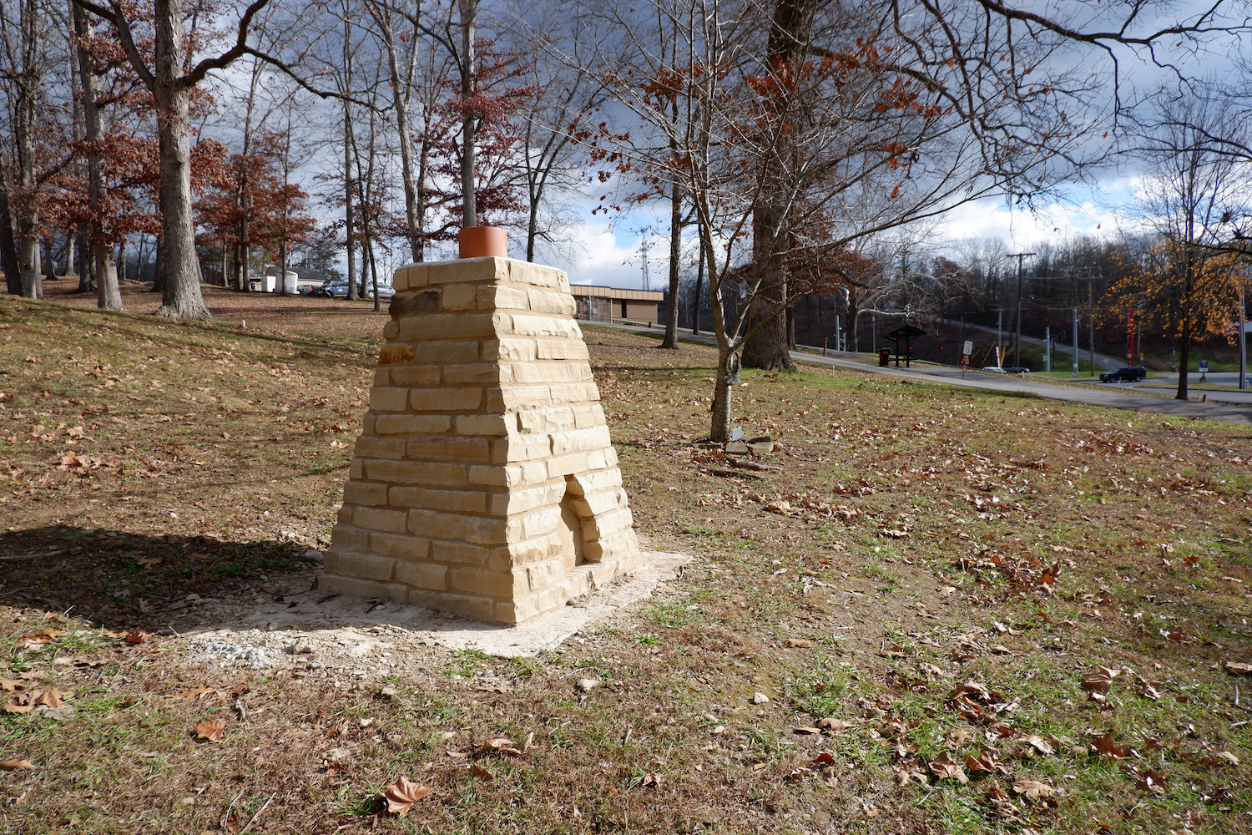
- CAPTION: The Asbury Parker Memorial at ARMCO Park in Ashland, Kentucky commemorates the 1857 escape of Asbury Parker from slavery at nearby Clinton Furnace. Built by Boyd County Parks and Recreation in collaboration with the Appalachian Freedom Heritage Tourism Initiative and the Center for Public History at Shawnee State University, the memorial interprets Parker’s daring flight through Huntington, West Virginia, and Ironton, Ohio to freedom in Ontario, Canada. Located near the site of his enslavement, the memorial honors both Parker’s courage and the Underground Railroad network that aided his journey. Photo Credit: Andrew Feight, Ph.D., Appalachian Freedom Heritage Tourism Initiative.
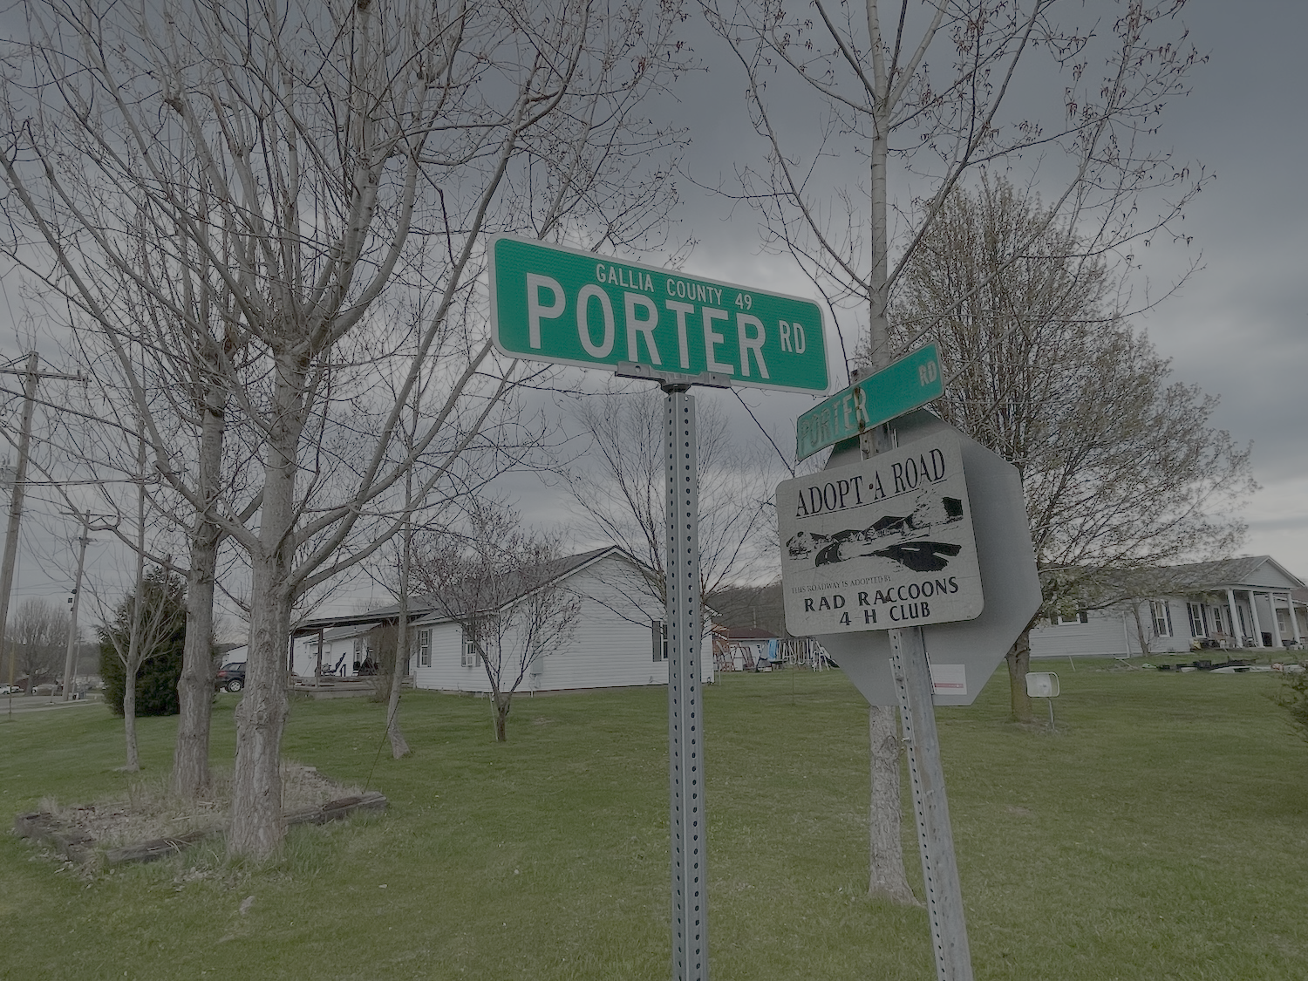
- CAPTION: Payne’s Abolition Corner, also known as Payne’s Store and the Porter Post Office, served as a key Underground Railroad station in Gallia County. In the fall of 1845, Pleasant and Dave—two enslaved brothers fleeing Greenup County, Kentucky—were hidden here by George and Harriet Payne before being guided north toward freedom, part of a network that assisted hundreds passing through the region. Photo Credit: Andrew Feight, Ph.D., Appalachian Freedom Heritage Tourism Initiative.

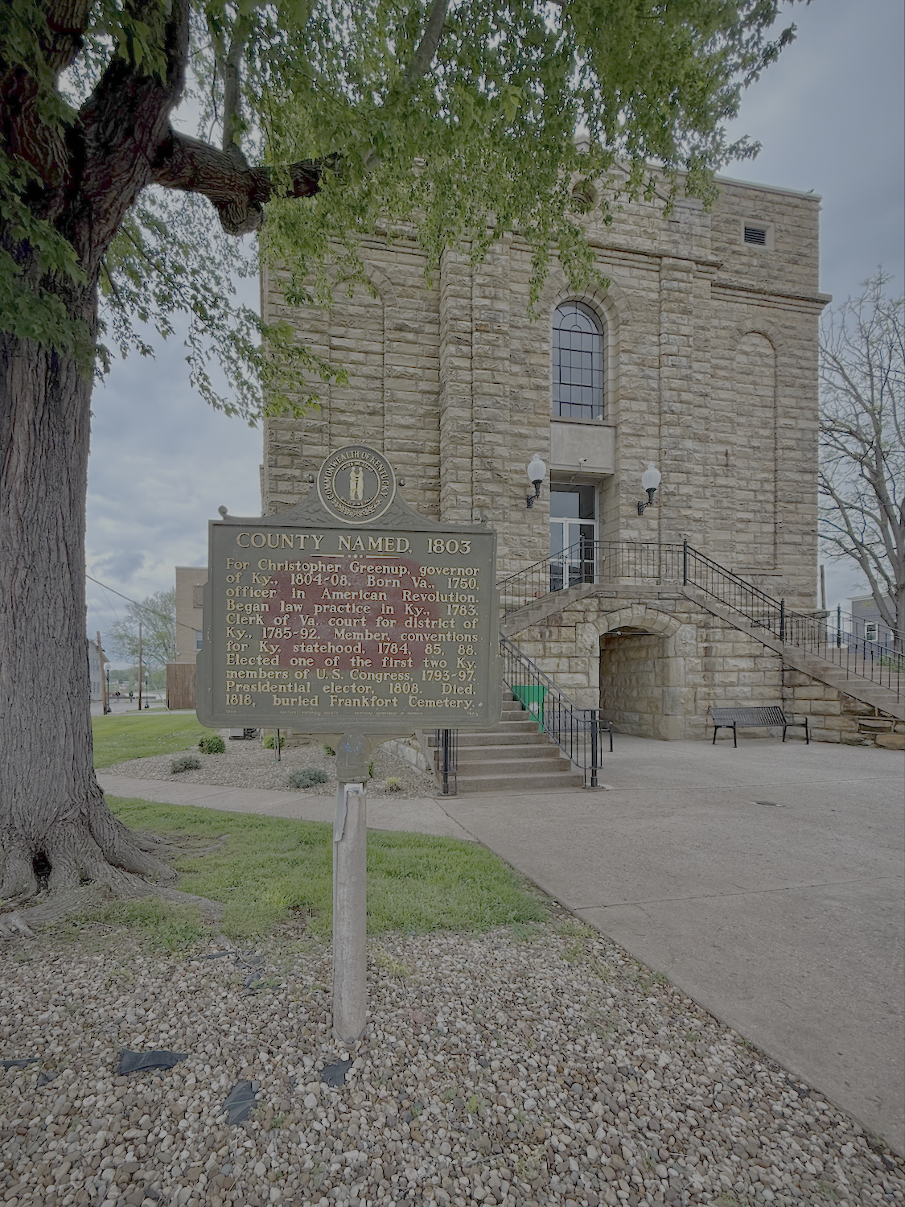

- CAPTION: The Greenup County Courthouse Square was laid out in 1803 on the banks of the Ohio River and soon became the site of multiple legal proceedings connected to slavery and the Underground Railroad, including freedom suits and prosecutions for assisting enslaved people to escape. The adjacent jail held captured freedom seekers and kidnapped free Blacks, underscoring the legal risks faced by those who challenged slavery in the border region. Photo Credit: Andrew Feight, Ph.D., Appalachian Freedom Heritage Tourism Initiative.

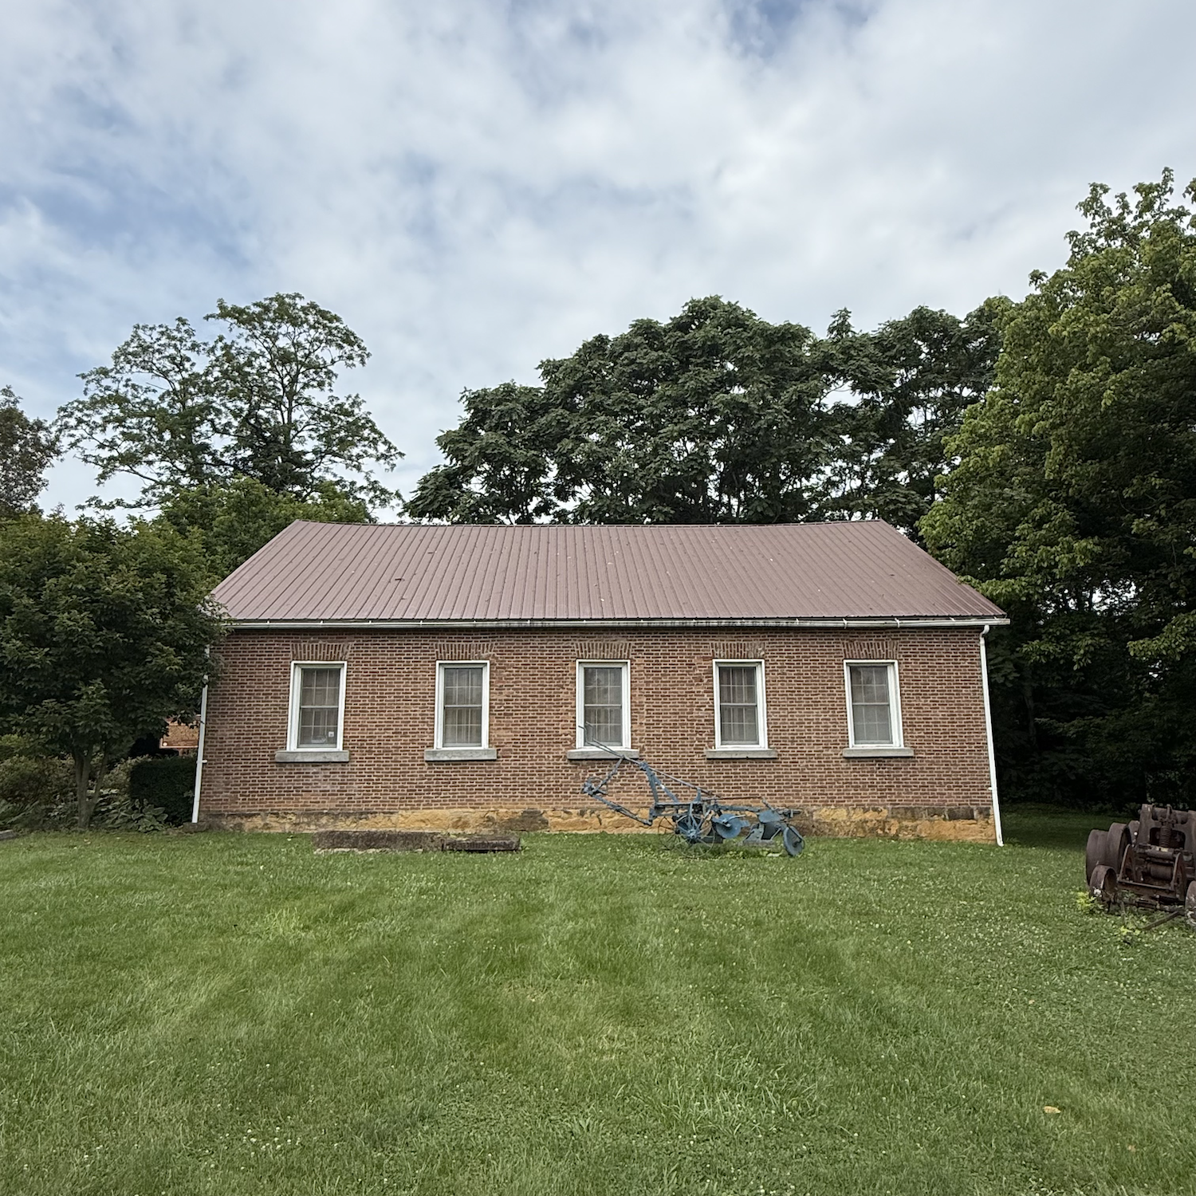
- CAPTION: Joe Logan and the West Union Associate Reformed Presbyterian Church — Constructed in 1835 and now home to the Adams County Historical Society, the West Union Associate Reformed Presbyterian Church has been added to the Network to Freedom for its association with Rev. John Graham, who served as pastor of the congregation from 1840 until his death in 1849. Together with Joe and Jemima Logan, Graham helped organize and sustain an interracial, faith-based Underground Railroad network that aided freedom seekers moving through Appalachian Ohio. Photo Credit: Andrew Feight, Ph.D., Appalachian Freedom Heritage Tourism Initiative.

